Author: Aniket Ganesh Padwal

Amazon Sales Analysis Report

**Amazon Sales Analysis Report**

Date: 26/06/2024

Author:

Aniket Ganesh Padwal

**Table of Contents**

1. Executive Summary

2. Introduction

3. Data Loading and Cleaning

4. Sales Overview

5. Product Analysis

6. Fulfillment Analysis

7. Customer Segmentation

8. Geographical Analysis

9. Insights and Recommendations

10. Conclusion

11. Tableu Dashboard

**Executive Summary**

This report provides a comprehensive analysis of Amazon sales data, uncovering key insights and actionable recommendations. The analysis highlights sales trends, product preferences, fulfillment effectiveness, customer segmentation, and geographical distribution. Key recommendations include targeted marketing strategies, optimized inventory management, and improved customer service to drive revenue growth and enhance customer satisfaction.

**Introduction**

The purpose of this report is to analyze Amazon sales transactions to extract actionable insights that support business decision-making. The dataset includes details such as order ID, date, status, fulfillment method, sales channel, product category, quantity, amount, and shipping information. The analysis focuses on understanding sales performance, product preferences, fulfillment effectiveness, customer behavior, and geographical sales distribution.

**Data Loading and Cleaning**

The dataset was loaded and cleaned by filling missing values with the mode and converting necessary columns to appropriate data types. Summary statistics were calculated to understand the dataset's key characteristics.

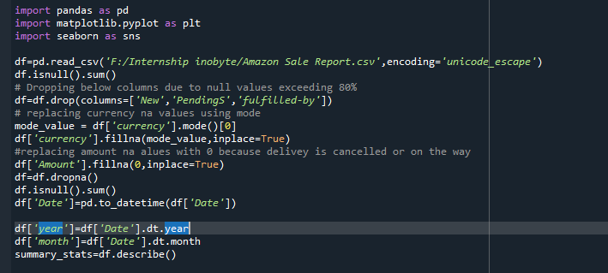

**Sales Overview**

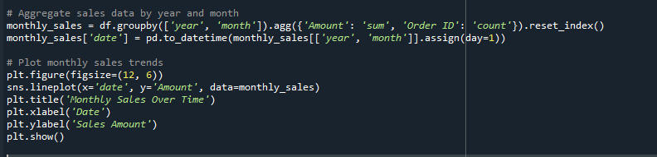The analysis of overall sales performance revealed consistent growth in monthly sales. Key performance metrics such as total sales and average sales per month were calculated. The line plot below illustrates the sales trends over time.

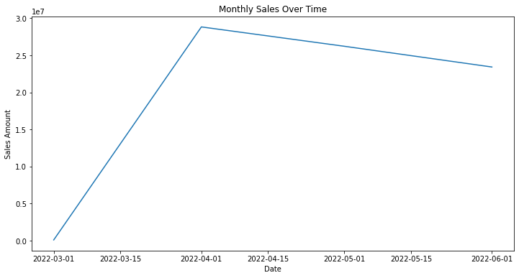

**Product Analysis**

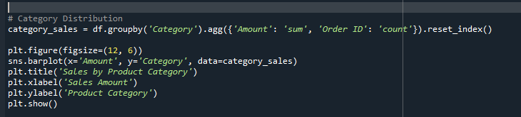The distribution of product categories, sizes, and quantities sold was analyzed. Bar plots showing sales by product category highlighted the top-selling products. The analysis revealed that categories such as electronics and home goods were the most popular.

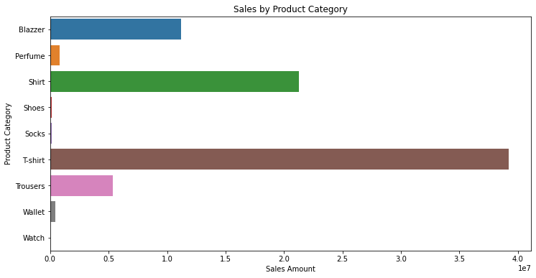

**Fulfillment Analysis**

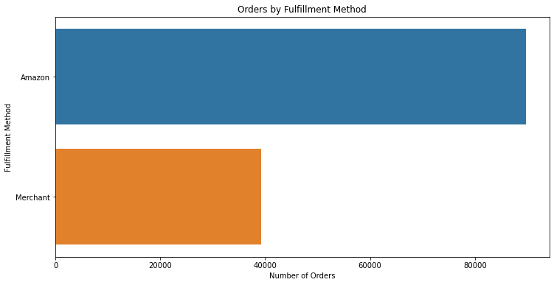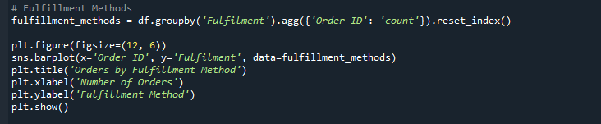The effectiveness of different fulfillment methods was investigated. The bar plot below shows the number of orders by fulfillment method. The analysis indicated that certain fulfillment methods were more effective in delivering orders on time.**Customer Segmentation**

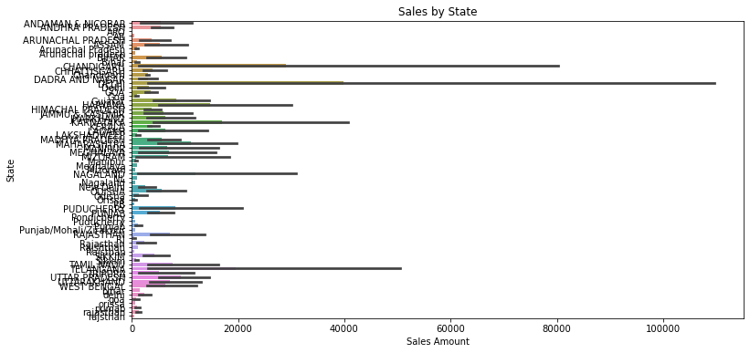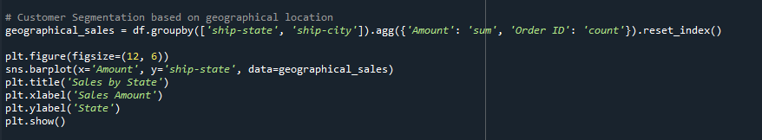Customers were segmented based on their purchasing behavior and geographical location. The count plot below shows customer segments by spending. The analysis revealed distinct segments such as high-spending customers, which can be targeted for personalized marketing campaigns.

**Geographical Analysis**

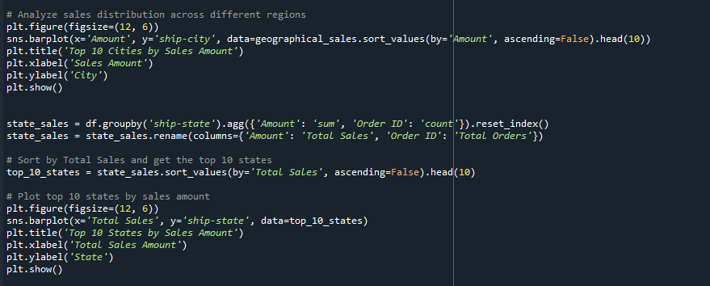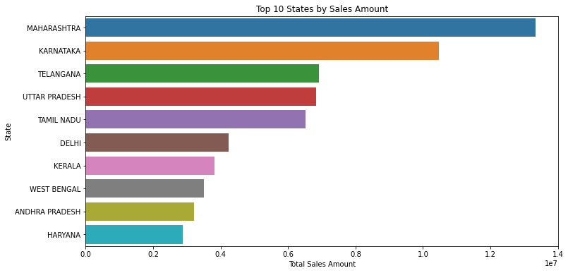The geographical distribution of sales was explored, focusing on the top 10 states and top 10 Cities by sales amount. The bar plot below shows sales by state, city, highlighting the states and cities with the highest sales.

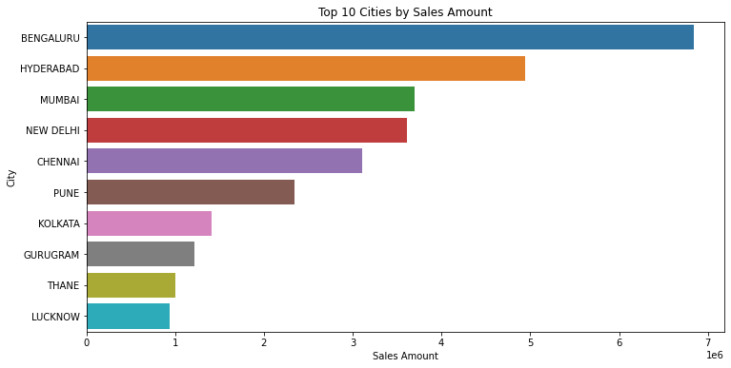

**Insights and Recommendations**

Key findings from the analysis include consistent sales growth, popular product categories, effective fulfillment methods, and significant customer segments. Actionable recommendations include targeted marketing strategies, optimized inventory management, and improved customer service to drive revenue growth and enhance customer satisfaction.

**Conclusion**

This report provided a comprehensive analysis of Amazon sales data, uncovering key insights and actionable recommendations. By leveraging these insights, the business can optimize operations, enhance customer experience, and drive revenue growth. Further analysis can focus on more granular customer behavior and product trends.

**Tableu Dashboard**

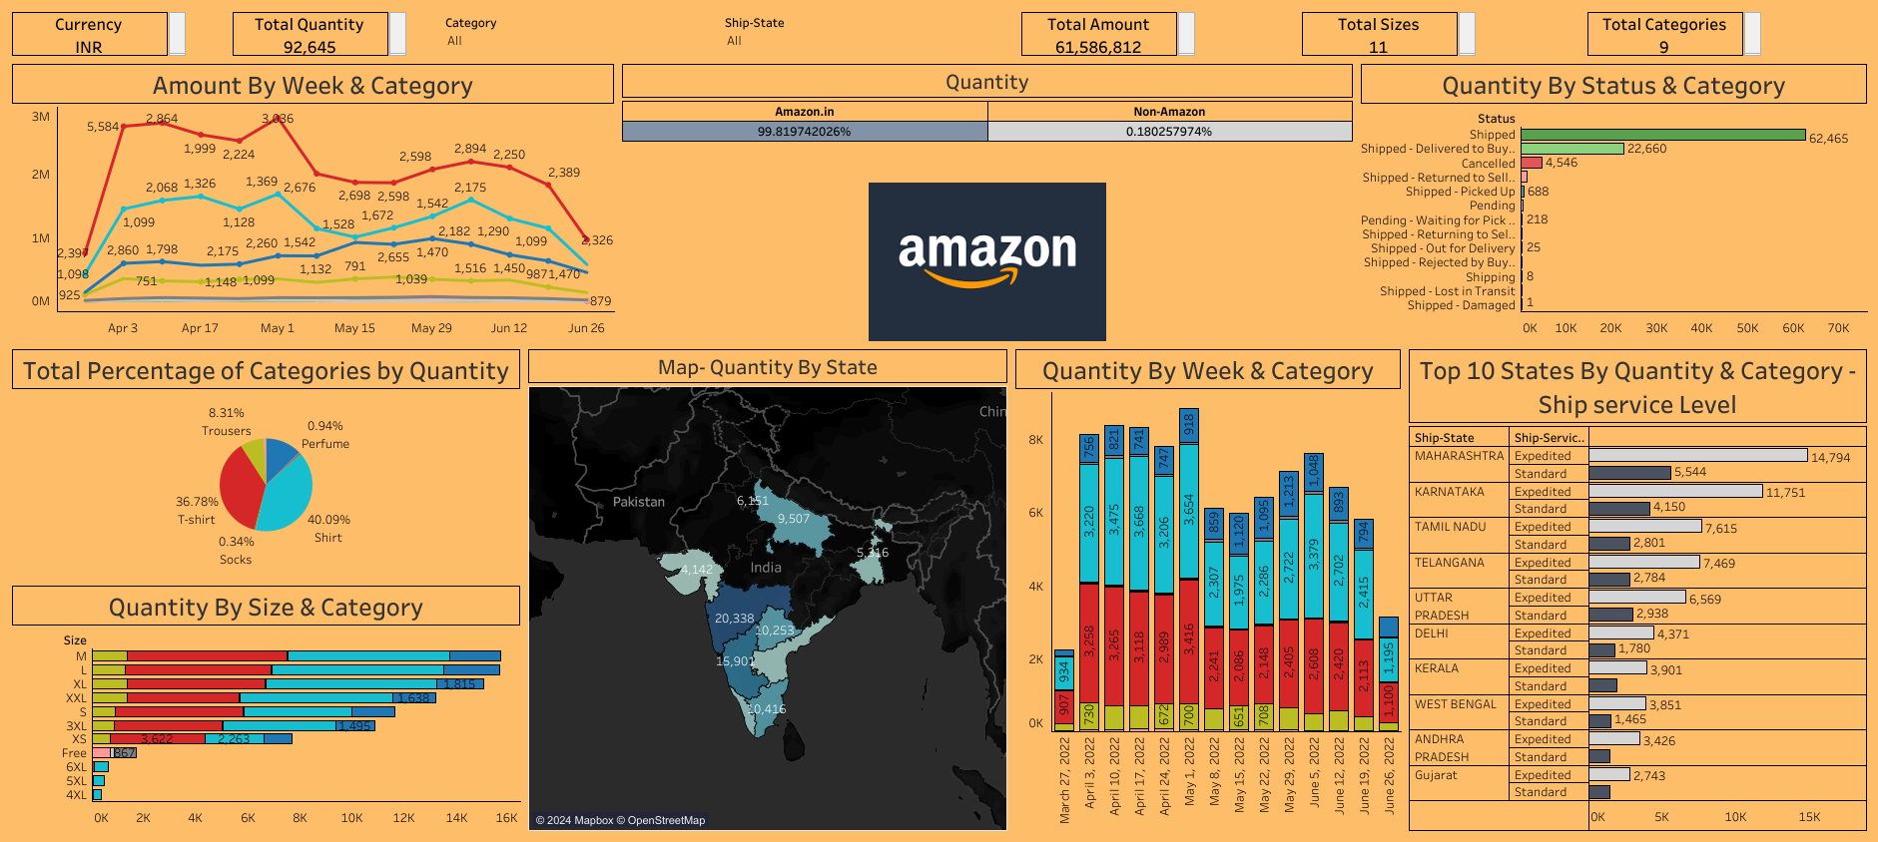Link: <https://public.tableau.com/app/profile/aniket.padwal8813/viz/sales_analysis_17193780151850/Dashboard1?publish=yes>